2026
Romarno Basson
45401004
2/22/2026
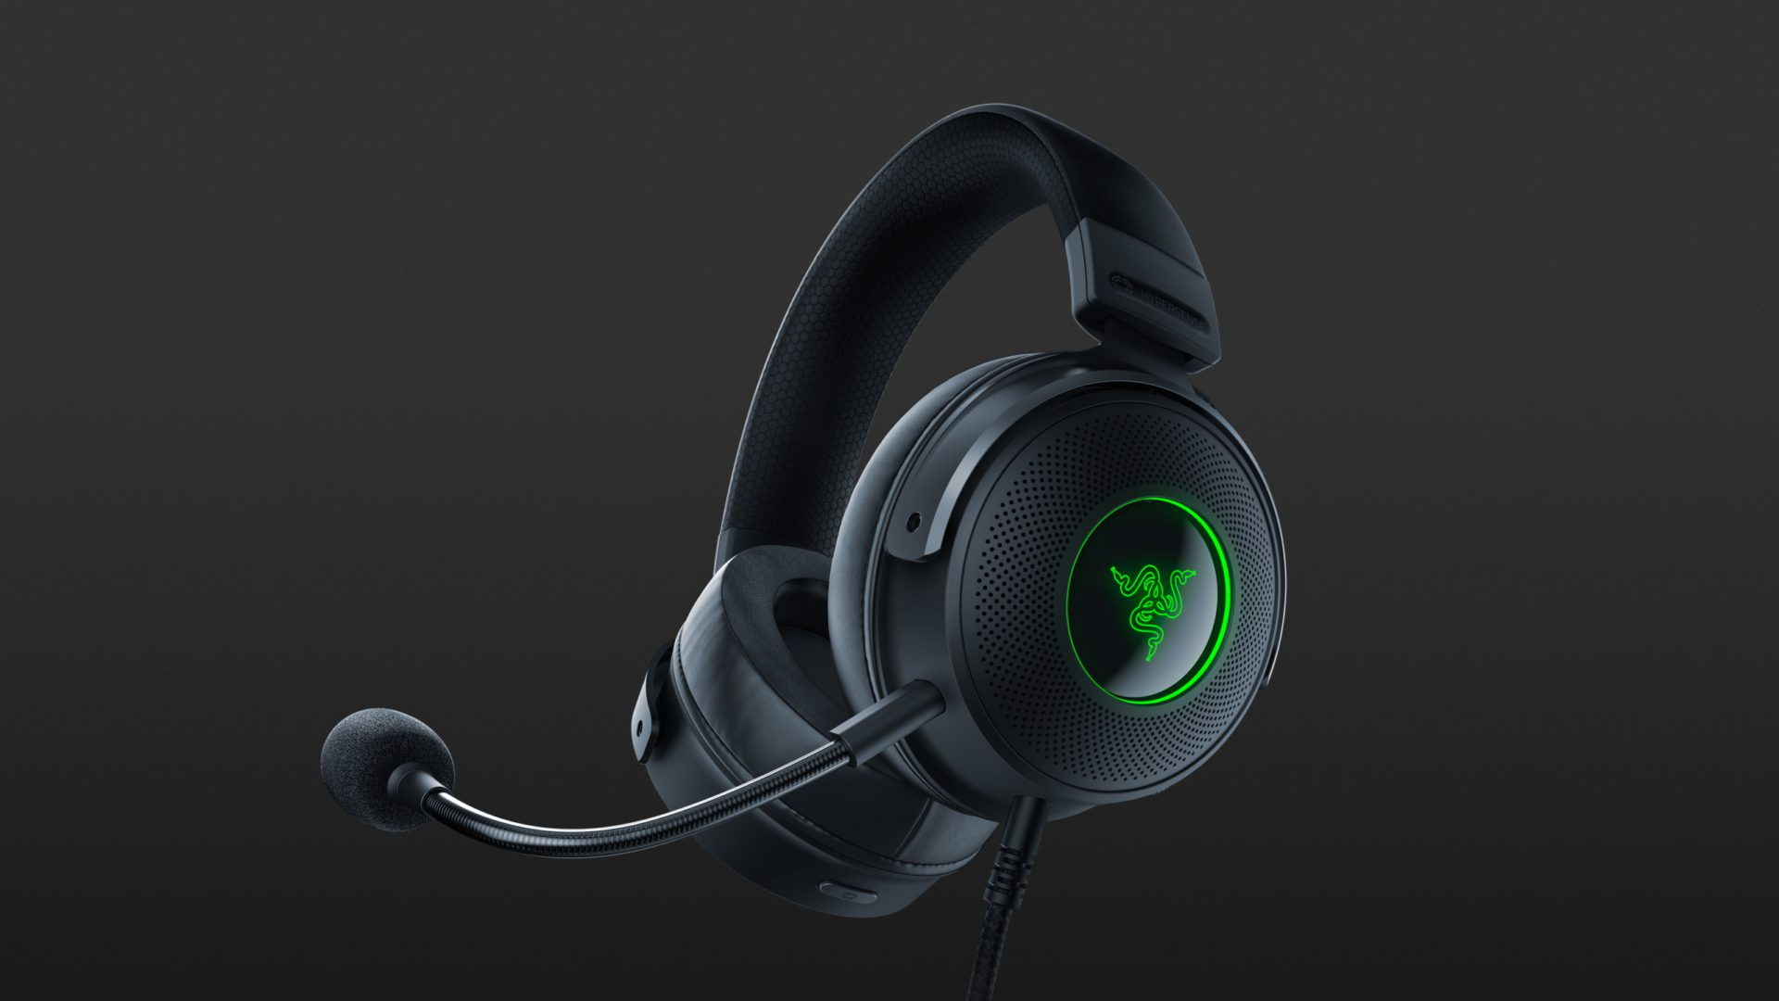
Teaching My Machine to Recognize My Headset
Introduction (pre GPT)
In Cmpg 313 we are taught about the use and history of AI. We were tasked early on in the module to create our own teachable machine model. I realised that most of my days I spend at my desk with my headset on and started wondering if it is even safe to be able to wear a headset all day or not, so I decided I would create my own headset recognition software sothat I can accurately detect when I have had my headset on for too long.

In a recent study done by the American Osteopathic Association it is found that 1 in 5 teens will experience some form of hearing loss. As a rule of thumb, Dr.Foy stated “You should only use MP3 devices at levels up to 60% of maximum volume for a total of 60 minutes a day.” With this in mind, I put my efforts toward learning my teachable machine to accurately detect when I have my headset on and when I don’t.
At first I though it was going smoothly when I turned my webcam on and started recording around 163 image samples without my headset and 146 samples with my headset. This was easily done with my built in webcam and the video sample taking functionality on the Teachable Machine program.
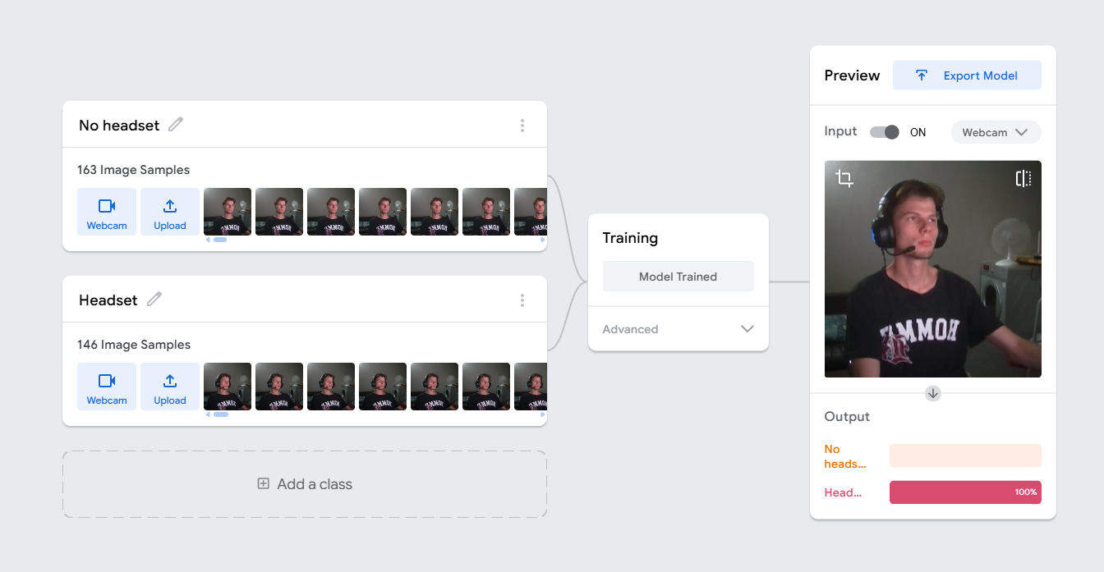

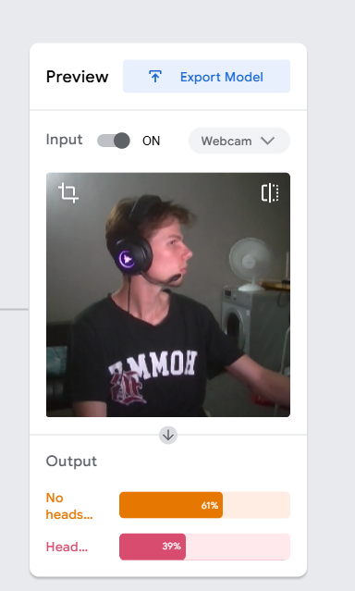
I thought this would be more than enough but I soon saw in testing that it barley recognised my headset if I turned my face even though it is clearly still on my head. Luckily this was not an issue as I can just record more photos of myself with and without the headset.
I continued to upwards of 400 photos for each scenario but still, there was always a different way the headset will stop detecting.
I then decided to just keep on recording photos, all the way till I had 550 image samples of my headset and 556 of me without the headset.
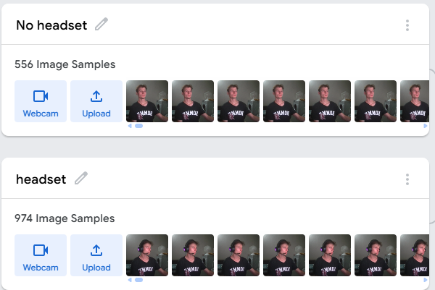
This turned out to be a lot more efficient than only having 100+ photos.
But sadly it was still not accurately detecting when I had my headset on. I assumed it was because of the placement of my microphone and went to retrain my model of 400 more sample images where my microphone was in different positions.
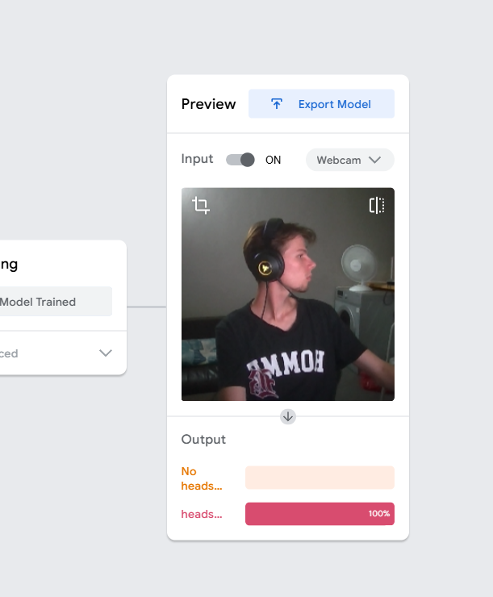
This turned out to be the exact reason it still doubted itself since it started very accurately detecting my headset in all kinds of positions.
Now all I still have to do is make it time how long I have my headset on my head for sothat I can get frequent reminders to take a break and rest my ears before I continue with my headset on.
https://osteopathic.org/what-is-osteopathic-medicine/headphones-hearing-loss/#:~:text=%E2%80%9CAs%20a%20rule%20of%20thumb,about%20five%20minutes%20a%20day.%E2%80%9D
https://www.headphonecheck.com/test/razer-kraken-v3-hypersense/

AI Section
My prompt: 
{insert report here (too long)}
AI response:
Here is a refined, academic version with improved grammar, tone, and flow, plus NWU Harvard-style references.

Introduction (pre-GPT)
In CMPG 313, we are introduced to the use and history of artificial intelligence (AI). Early in the module, we were tasked with creating our own Teachable Machine model. I realised that I spend most of my day at my desk wearing a headset, which led me to question whether it is safe to wear a headset for extended periods. Consequently, I decided to develop a headset recognition model that can accurately detect when I have been wearing my headset for too long.
A recent study by the American Osteopathic Association indicates that 1 in 5 teenagers experiences some form of hearing loss. As a rule of thumb, Dr Foy advises: “You should only use MP3 devices at levels up to 60% of maximum volume for a total of 60 minutes a day.” With this in mind, I focused on training my Teachable Machine model to accurately detect when I am wearing my headset and when I am not.
Initially, the process appeared to be successful. Using my built-in webcam and the video sampling functionality of Teachable Machine, I captured approximately 163 image samples without my headset and 146 samples with my headset. However, during testing, I noticed that the model barely recognised the headset when I turned my face, even though it was clearly still on my head. Fortunately, this issue could be addressed by recording additional images of myself both with and without the headset.
I increased the dataset to over 400 images for each scenario, yet the model still failed to detect the headset reliably in certain situations. I continued collecting data until I had 550 images of myself wearing the headset and 556 images without it. This larger dataset proved to be significantly more effective than the initial 100+ images.
Despite this improvement, the model still struggled with accurate detection. I suspected that the microphone placement was affecting the results, so I retrained the model using an additional 400 images featuring different microphone positions. This proved to be the key issue, as the model subsequently detected the headset accurately across a wide range of positions.
The remaining step is to implement a timing function that tracks how long I wear the headset, allowing me to receive regular reminders to take breaks and protect my hearing.

References (NWU Harvard Style)
American Osteopathic Association. n.d. Headphones and hearing loss. Available at: https://osteopathic.org/what-is-osteopathic-medicine/headphones-hearing-loss/ (Accessed: 24 February 2026).
Headphonecheck. n.d. Razer Kraken V3 Hypersense test. Available at: https://www.headphonecheck.com/test/razer-kraken-v3-hypersense/ (Accessed: 24 February 2026).

